Behaviour Planning

- used to provide guidence to the trajectory planner as to what sorts of maneauvers they should plan trajectories for.

Looking at the processes in a self driving car, and the frequency with which they should be running.

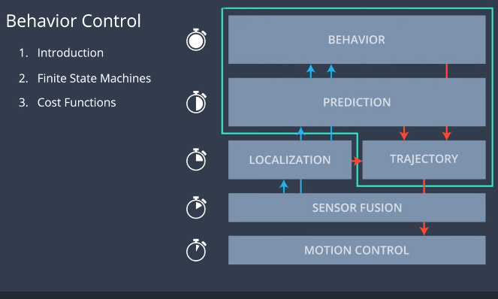

The reason why the behavior planning portion of path planning is a comparatively long timespan is due to the fact that it has to incorporate alot of data in order to make decsisions about fairly long time horizons in the order of 10 seconds or longer.

In this lesson, we will use behavior control as a finite state machine, but in the real world, graph structure is used to solve this problem.

Understanding the Output

We need to be able to make suggestions that are as nuanced as “stay in your lane but get behind that vehicle in the right lane so that you can pass it when the gap is big enough”, and we can with only specifying a few quantities.

Example:
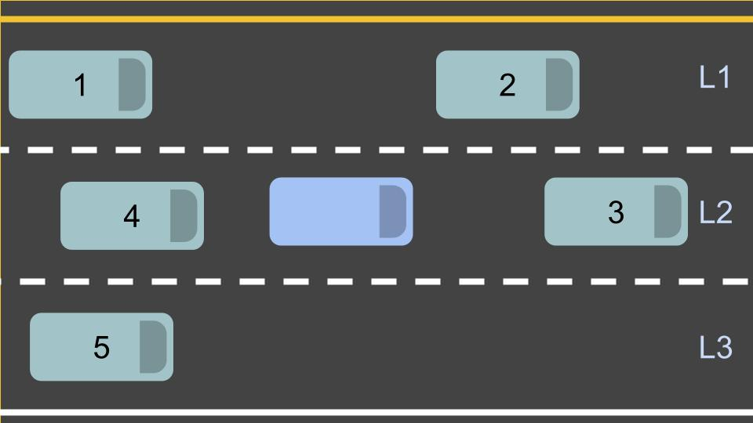
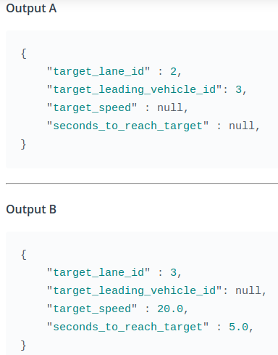

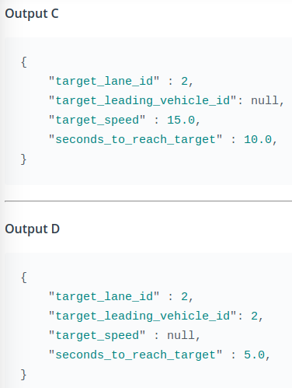

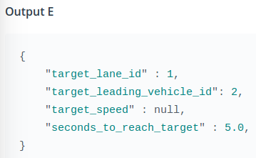

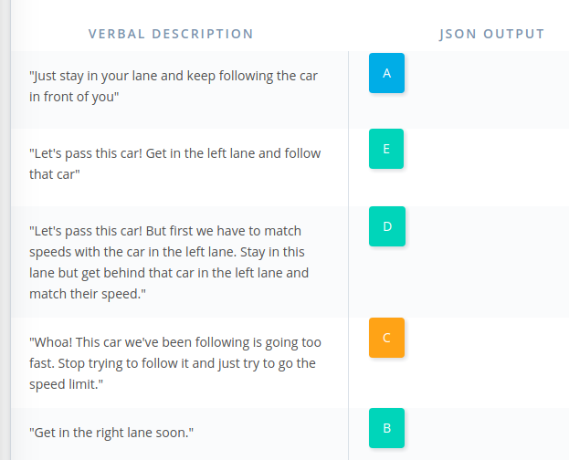

The Behaviour Problem

You can think of behaviour planning like a passanger of a vehicle with google maps, and a path to the destination in hand. The driver themselves does not really care where the destination is, so the passenger can tell them things like “We need to turn left soon”, and the driver will then act alone in determining if it is safe to go into the left lane and prepare for a future maneauver.

Behaviour planner uses its inputs to produce suggested maneuvers that the trajectory planner is repsonsible for reaching collision free and safely.
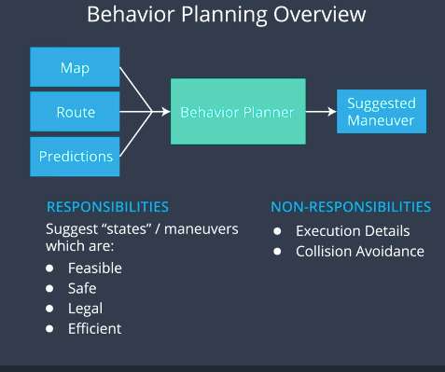

Finite State Machines

With the assumption that there arent realy that much types of suggestions we get from a navigator in terms of behaviour, we can use a finite state machine.

A finite state machine makes decisions based on a finite set of discrete states.

At the start, the finite state machine starts in an initial state, like s0.

Each state is connected by 1 or more transition, and sometimes, there is a transition back to the same state.

Also not all transitions are necessariy possible. Like s4 cant transition to another state. (called an Accepting State)

To transition from one state to another, you require an input, and some sort of state transition function that takes that input, and decides what transition to make.

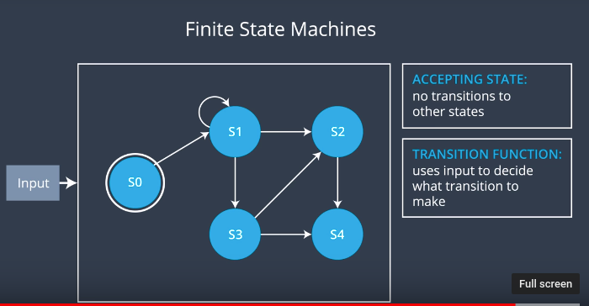

Example:

Vending machine where everything costs 20 centes, and requires exact change.
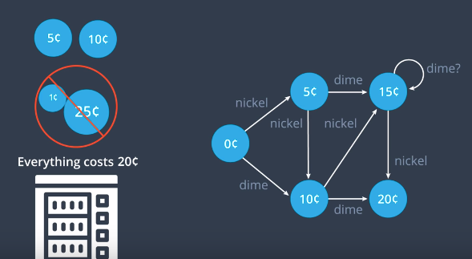

Strengths:
- Easy to reason about, and are basically self documenting due to the fact that they map the logicial state of a system directly to the physical state

- Maintainable, For example if we wanted to change the cost of everything to 25 cents, we would just require one more state (For small state spaces)

Weaknesses:

- Easily abused, menaing if they arent asigned well to begin with or the problem changes, you can find yourself saying things like “I hadn’t considered that, lets just add another state”

- Not Maintainable (For large state spaces)

If we wanted to start accepting pennies, we would require a state for every intege from 0 to 25. This means that we would be required to add 26 – 6 = 20 states.

Finite state machine for a self driving car on a highway

If you are the only lane in your road, you would need a state for keeping in your lane, changing lanes, left, changing lanes right,

What if we have a vehicle in front of us? It would be useful to have a state to follow the vehicle in front of us or pass it. But does passing it really require another state due to the fact that it really is just a lane change to the left, and then a lane change to the right?

With more vehicles, we should really have a slow down state, which also means we need a speed up state, and a stop state. Or we can do all of this at once by having a keep target speed state.

Maybe we can just have a state for prepare lane change left, so that the vehicle knows to combine both get an open gap between vehicles in another lane, and then put on your turn signal and change lanes.

In reality, there is no single correct set of states to choose from. On one hand, you want to keep the state space as small as possible for maintainability, but on another hand you want to have enough of the logical states to represent the physical states that we care about.

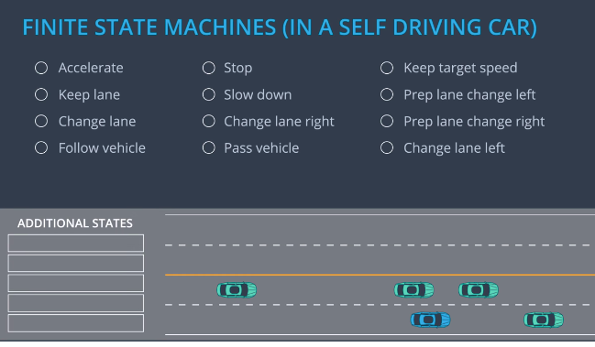

What states shall we choose for the upcomming examples?

We decided to use the bare minimum which is 3, keep lane, change lane left, and change lane right, as well as the prepare lane change left, and prepare lane change right.

We require the prepare lane change due to the fact that otherwise, we would just wait for lane change to be right next to us otherwise, which is not great. Secondly, ideally you want to match the speed of the other lane before you change into it, which we cant do with just 3 states. Also turning the signal on is the repsonsibility of the behaviour planning team, and we require it to be on for a few seconds before the maneavuer is executed.

With the prepare for a lane change state, we now have a defined time to match speeds and signal the turn. Looking at the finite state machine, we can see that it is now not possible to change lanes without first preparing to do so.

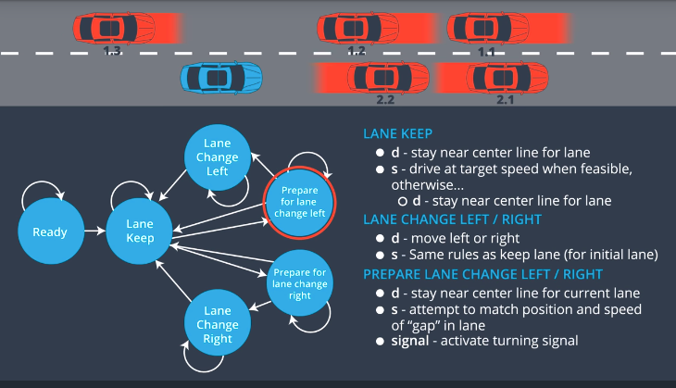

Now changing lanes is much more safer.

Inputs to Transition Functions

The process of getting our inputs and deciding which state to transision to is the essential part of a finite state machine.

What data will we need to pass to our transition function as inputs?
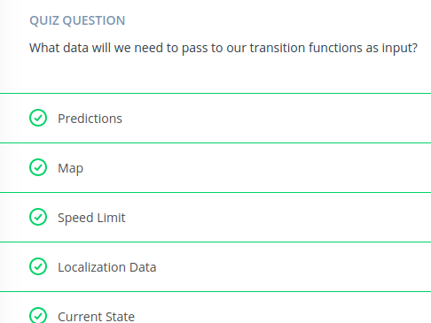

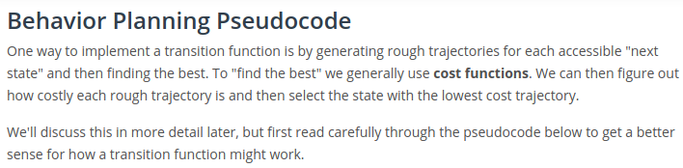
def transition_function(predictions, current_fsm_state, current_pose, cost_functions, weights):
# only consider states which can be reached from current FSM state.
possible_successor_states = successor_states(current_fsm_state)

# keep track of the total cost of each state.
costs = []
for state in possible_successor_states:
# generate a rough idea of what trajectory we would
# follow IF we chose this state.
trajectory_for_state = generate_trajectory(state, current_pose, predictions)

# calculate the "cost" associated with that trajectory.
cost_for_state = 0
for i in range(len(cost_functions)) :
# apply each cost function to the generated trajectory
cost_function = cost_functions[i]
cost_for_cost_function = cost_function(trajectory_for_state, predictions)

# multiply the cost by the associated weight
weight = weights[i]
cost_for_state += weight * cost_for_cost_function
costs.append({'state' : state, 'cost' : cost_for_state})

# Find the minimum cost state.
best_next_state = None
min_cost = 9999999
for i in range(len(possible_successor_states)):
state = possible_successor_states[i]
cost = costs[i]
if cost < min_cost:
min_cost = cost
best_next_state = state

return best_next_state

Obviously we are glossing over some important details here. Namely: what are these cost functions and how do we create them? We'll talk about that next!

Create Cost Function

Speed Cost

Getting transitions to happen when we want them to is to design reasonable cost functions.

We want to penalize and rewared the right things.

So how do we associate cost to the speed of a vehicle, well we want to get to our desitination quickly, but we also dont want to break the law. So we need a way to associate each velocity with a cost.

For simplicity, we can assume that each cost function has an output between 0 and 1.

What we can do is set a 0 cost to a speed a little below the speed limit so that we have a buffer, and a max cost at the limit.

The cost of not moving at all however should be very high, but maybe not as high as breaking the law.

Something like this would work.
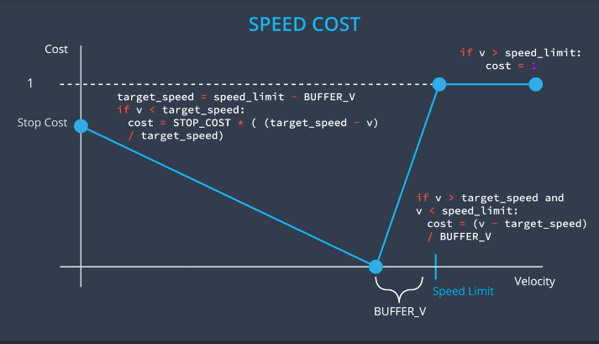
In practice it is usefull to parameterize each of these points so that we could later adjust them until we get the right behaviour. We define them as stop cost and the buffer velocity.

We have 3 domains now with 3 different cost functions, slower than the target speed, above the speed limit, and between the target speed and the speed limit.

Lane Change Penalty

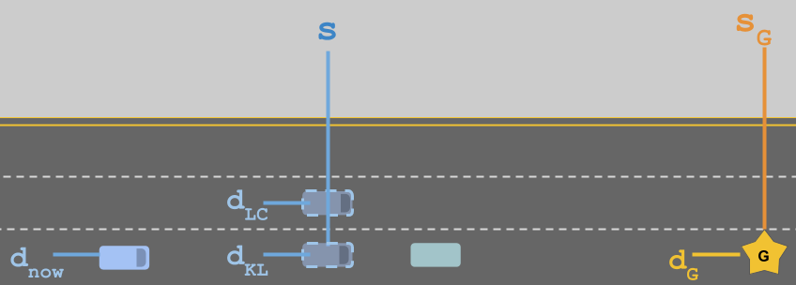
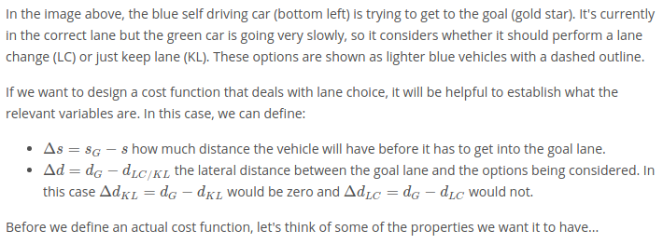
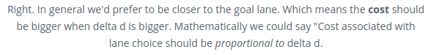
With delta d:

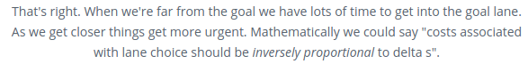
With delta s:

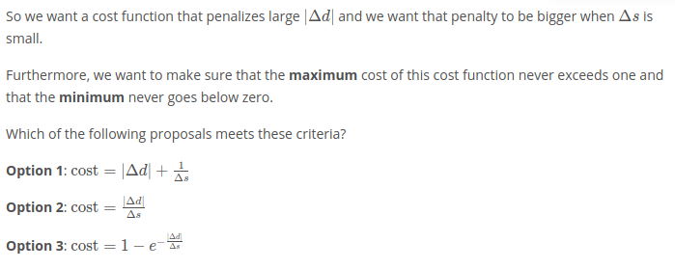
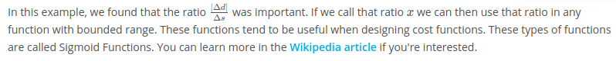

Cost Function Design and Weight Tweaking

Design is dificult and getting them all to co-operate to get a desired vehicle behaviour is hard.

Dificulties

- We can find that the vehicle is behaving reasonably well except for some particular situtations. In an effort to solve this problem you add new cost functions, tweak existing ones, or modify the weights. But every time we do this, there is a chance we break a chain of something that already works.

This is solved with regression testing! We define a set of situtations, each with their own expected behaviour, and then whenever a change is made, we simulate the vehicle in all of our test cases and ensure it still behaves as expected. (Extremely importatnt for software in safety critical applications)

- Balancing costs of drastically different magnitudes. A way to solve this is to have weights which reflects the type of problem the cost function addreses. That way we can most heavily penalize any behaviour that isnt possible due to physics, then safety, legality, and comfort, efficiency.
The relative imporatnce of these weight may also be adjusted depending on the situdation. For example, if a light turns red, legality is more important than in a highway driving situtation.

- Ideally, each cost function serves a very specific responsibility. Our speed cost function tried to balance desire to drive quickly, which had to do with efficiency, with our desire to not exceed the speed limit, which is legality. Ideally they would both be seperate cost functions. That way each cost function does have its own very specific responsibility.
In that case we can just have a binary function that checks wheter we are breaking the speed limit and a cuntinous cost function that pulls us towards the target speed.
With each cost function being sepearted by responsibility (safety, legality, feasibility, efficiency, etc.), we can make each cost functions output between -1 and 1.

- Parameterize whenver possible, that way we can use some parameter optimization techniques like gradient decent, and our regeression tests to programaticaly tweak our cost functions.

-Thinking in terms of vehicle state is also very helpful. (Position, velocity, acceleartion)

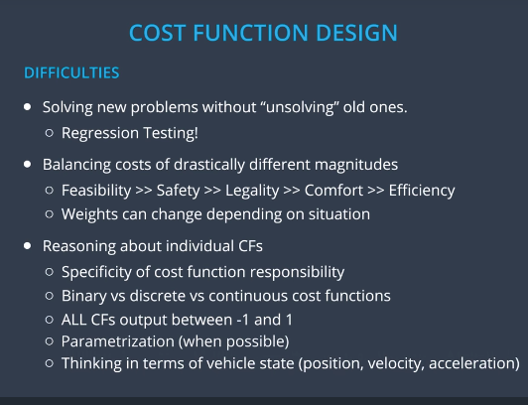

Example:

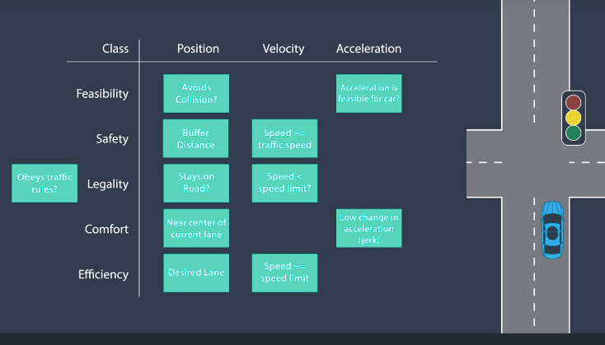
Adjusting the weights to each class depending on the situtation, as well as seeing where overlapping considerations are is very difficult and complex. However this is a complex problem, and there is no way to completely simplify it.

Considering that for speed, we have a binary cost function for whether we are above the speed limit or not, we can make our efficiency cost function for speed a parabala that can go above the speed limit due to that being already taken into account.
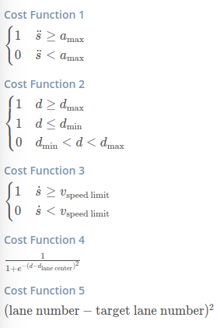
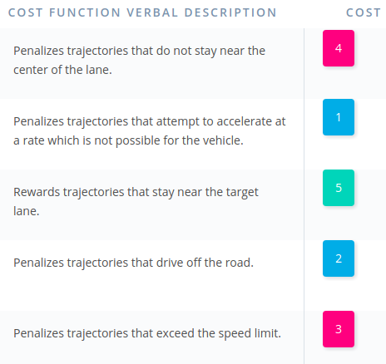

Scheduling Compute Time

It makes sense that the Behaviour planning component requires more time due to the considerations being made over a long horizon, the amout of data required from other segments of a self driving car, and the fact that they just dont change frequently.

Howevery it is important that the we consider that the trajectory module does require our decisions, and its important that the overall system doesnt allow for a comparatively slow module like behaviour to clog up the proper functioning of the other faster components.

Example of 2 processing cycles of the behaviour module.

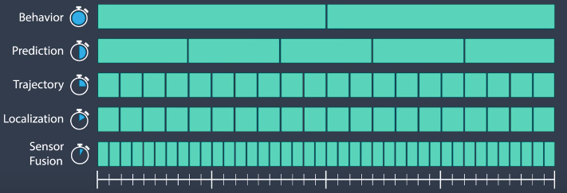

In this example, at the end of 1 behaviour cycle, we know that for the second behaviour cycle, we require prediction and localization data.
Because at this timestep, localization has new data, we can just use it. However prediction is actually right in the middle of an update cycle. Behaviour should never just wait until prediction is done, so what do we do?

What we do is accept that data that we have and the fact that it is a little old. The code provided for the path planning project already handles this, but it important to know.
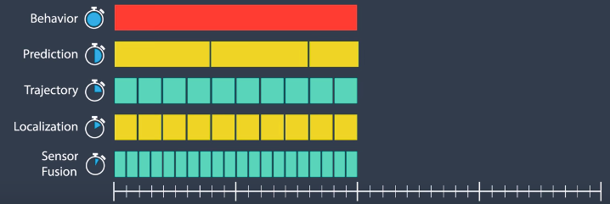

Conclusion

Finite State Machines work well as a solution to the behaviour planning problem.
They generally do well for small state spaces like highway driving. For more complex scenarios like urban driving, other approaches are more suitable.

